Q1. Sad guru’s Amrit -tulya Tea shop (AS per discussion with Aishwarya needs to write functional TCs).

**Frontend Test cases:-**

|  |  |  |
| --- | --- | --- |
| **S.N** | **TCs** | **Automation criteria** |
| 1. | User should able to open the Amrit-tulya tea shop website after launching the URL. | Can be Automated |
| 2. | User should able to view the items with price tag on home page. | Can be Automated |
| 3. | User should able to select the item after clicking on ‘select’ button to add in cart. | Can be Automated |
| 4. | User should able to view cart | Can be Automated |
| 5. | User should able to see price tag along with items. | Can be Automated |
| 6. | User should able to see picture with items. | Can be Automated |
| 7. | User should able to search for item. | Can be Automated |
| 8. | User should able to see thumbnail with item | Can be Automated |
| 9. | User should able to add and remove item in inventory | Can be Automated |
| 10. | User should navigate to new page (product detail page) after clicking on item/Product. | Can be Automated |
|  | User should able to view price, name, description and photo of item on product/item detail page. | Can be Automated |

**Backend TCs:-**

|  |  |  |
| --- | --- | --- |
| **S.N.** | **TCs** | **Automation criteria** |
| **1** | **If user launches the valid amrit –tulya tea shop URL then it should hit the server and upload to user’s screen.** | Can be Automated |
| **2** | **Server should response the frontend on time, responsive time should be accurate.** | Can be Automated |
| **3** | **Database server should be searched when user enters any item name in search bar.** | Can be Automated |
| **4** | **Database server API should be responding frontend if item get searched in data base.** | Can be Automated |
| **5** | **Database** | Can be Automated |
| **6** | **Every item and its attributes should be linked and synced to the database.** | Can be Automated |
| **7** | **All the attribute should be stored in proper respective item manner, if user select any item’s price, description, image should be sent to front end.** | Can be Automated |
| **8** | **Database server API should be providing the item details on time when user select and want to see product details.** | Can be Automated |
| **9** | **Database API should be so quick so frontend can show all the details on time to user to avoid page loading time, misalignment.** | Can be Automated |
| **10** | **Database should have logs/records of all visitors.** | Can be Automated |

**Here for back end validation we can use below mentioned testing appoaches.**

1. **Database testing**
2. **ETL testing**
3. **Performance testing.**

***********************************************************************

Q3. Given URL - <https://www.bestundertaking.net/NewConnection.aspx>

Please find below suggestion/feedbacks on website as a Functional quality engineer and end user in terms of..

1. **Functionality :-**

* **On home page, when User is clicking on ‘Login’ button, its navigating below page but not able go back or home page its refreshing here itself.**

**On Below login page user is not able navigate to back or home.**

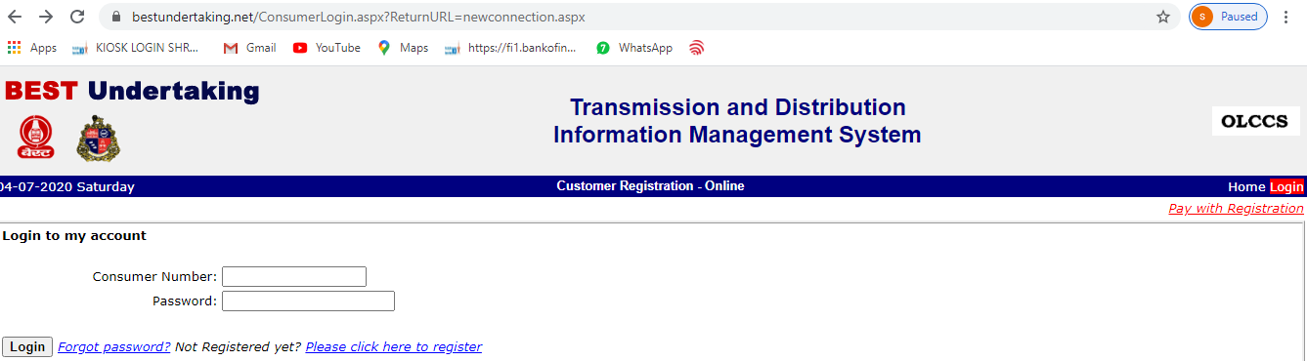

* **Preferred language in my electricity bill** should include Hindi’s radio button , since Hindi and English are official language and many people from all over India staying Maharashtra. Might chances they know only Hindi.
* **Time :-** Along with date there should be current time display to the homepage it will help to customers to at what time they have visited the site.
* **Uploading Photo:-** Uploading image size should be at least 50 KB since nowadays very has their Smartphone and it’s very difficult to upload 20KB JPG file.
* **Generate OTP:**- User should able to generate the OTP as of now it’s not generating the OTP**.**

**2. UI Aesthetics:** - The colour combinations and font size should be attractive, as of now colour combination not much attractive to the customer

3**. Usability:-** Its time taking form we can use many latest attributes like Drop downs, multiple text filed in single question like

3.1. User name:-

|  |  |  |
| --- | --- | --- |
| Name | Middle name | Last name |

Which will save rows and will avoid lengthy page length?

* 1. **Select Connection Type**\* 

we can use drop down instead of asking in radio button which will save extra length of page.

********************************ends here**************************

Thank you very much ......